

White Box Testing Document – Brain Age

**Project Advisor:**

Ms. Lehmia Kiran

**Group Members:**

Syed Asad Abrar (16L-4292), Taha Kibria (16L-4289)

National University Of Computer and Emerging Sciences

Department of Computer Science

Lahore, Pakistan

**1.** **Function:**

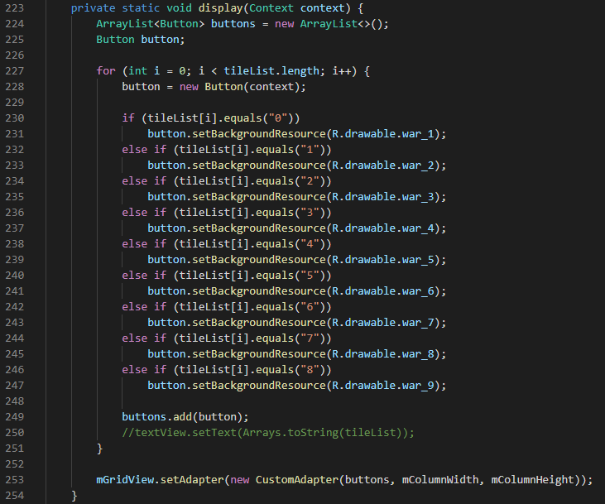

**2. CFG:**

(Diagram is a neat version of the rough drawing)

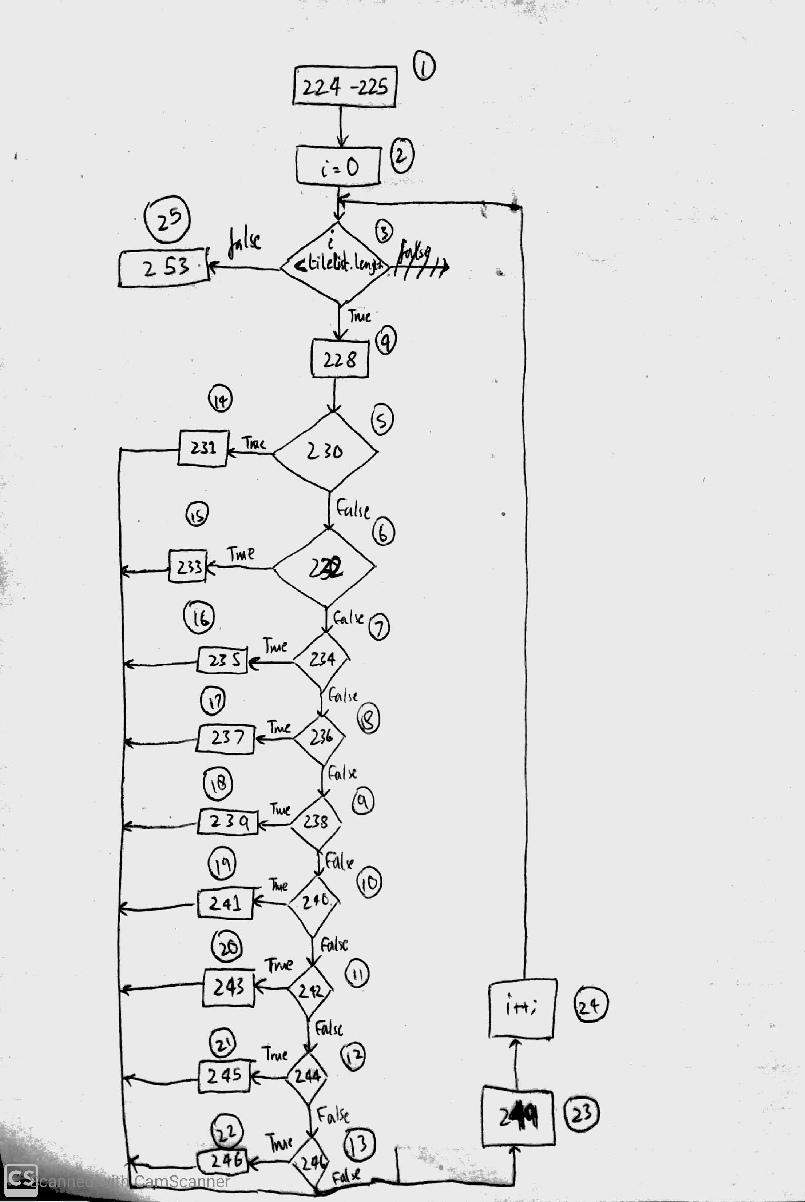

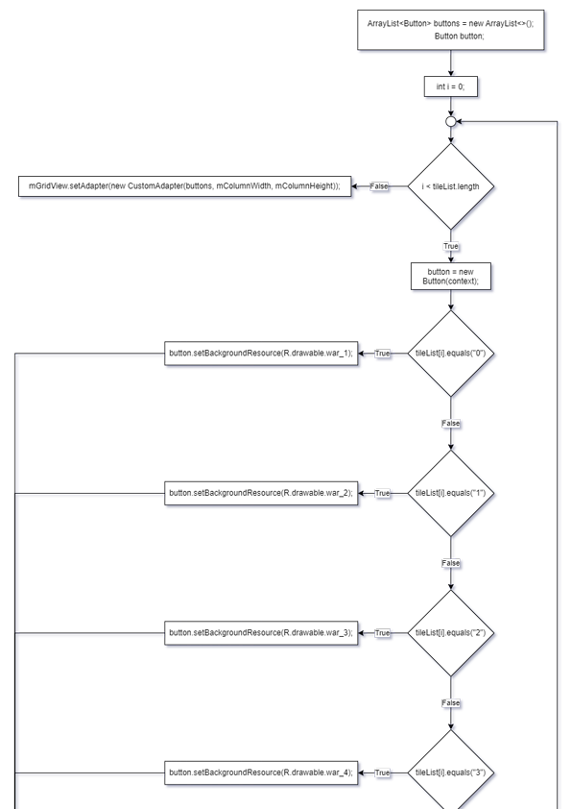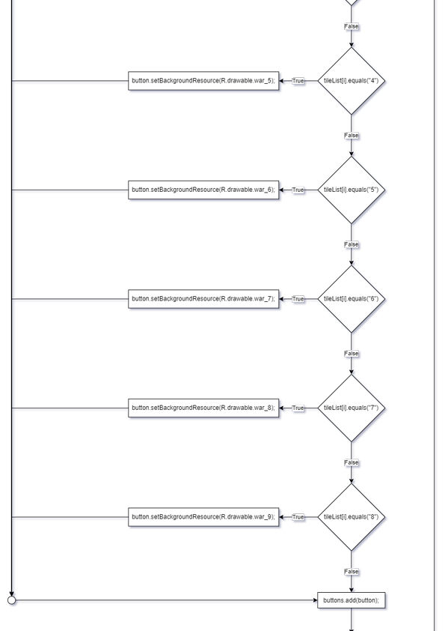

**3. Paths according to criteria**

We would use branch coverage and basis path coverage as the criteria. Paths according to the decided criteria are:

* 1 -> 2 -> 3(T) -> 4 -> 5(T) -> 14 -> 23 -> 24 -> 3(F) -> 25
* 1 -> 2 -> 3(T) -> 4 -> 5(F) -> 6(T) -> 15 -> 23 -> 24 -> 3(F) -> 25
* 1 -> 2 -> 3(T) -> 4 -> 5(F) -> 6(F) -> 7(T) -> 16 -> 23 -> 24 -> 3(F) -> 25
* 1 -> 2 -> 3(T) -> 4 -> 5(F) -> 6(F) -> 7(F) -> 8(T) -> 17 -> 23 -> 24 -> 3(F) -> 25
* 1 -> 2 -> 3(T) -> 4 -> 5(F) -> 6(F) -> 7(F) -> 8(F) -> 9(T) -> 18 -> 23 -> 24 -> 3(F) -> 25
* 1 -> 2 -> 3(T) -> 4 -> 5(F) -> 6(F) -> 7(F) -> 8(F) -> 9(F) -> 10(T) -> 19 -> 23 -> 24 -> 3(F) -> 25
* 1 -> 2 -> 3(T) -> 4 -> 5(F) -> 6(F) -> 7(F) -> 8(F) -> 9(F) -> 10(T) -> 19 -> 23 -> 24 -> 3(F) -> 25
* 1 -> 2 -> 3(T) -> 4 -> 5(F) -> 6(F) -> 7(F) -> 8(F) -> 9(F) -> 10(F) -> 11(T) -> 20 -> 23 -> 24 -> 3(F) -> 25
* 1 -> 2 -> 3(T) -> 4 -> 5(F) -> 6(F) -> 7(F) -> 8(F) -> 9(F) -> 10(F) -> 11(F) -> 12(T) -> 21 -> 23 -> 24 -> 3(F) -> 25
* 1 -> 2 -> 3(T) -> 4 -> 5(F) -> 6(F) -> 7(F) -> 8(F) -> 9(F) -> 10(F) -> 11(F) -> 12(F) -> 13(T) -> 22 -> 23 -> 24 -> 3(F) -> 25
* 1 -> 2 -> 3(T) -> 4 -> 5(F) -> 6(F) -> 7(F) -> 8(F) -> 9(F) -> 10(F) -> 11(F) -> 12(F) -> 13(F) -> 23 -> 24 -> 3(F) -> 25

Cyclomatic Complexity: P + 1 = 10 + 1 = 11

**4. Test Cases for each path:**

None of these paths can be tested since they do not take any input from user. Their also appears to be no bug while testing this function so no test cases can be made for white box testing of this function. The function has a for loop which iterates over a list of tiles which have number given to them from 0-9 and depending on the number, it adds resources to that button. Since, all of this is done without any user interaction and is basically how the game loads its UI so white box testing cannot be done for this. However, since this was the function given to us to test we made a CFG and paths for it.

**1. Function:**

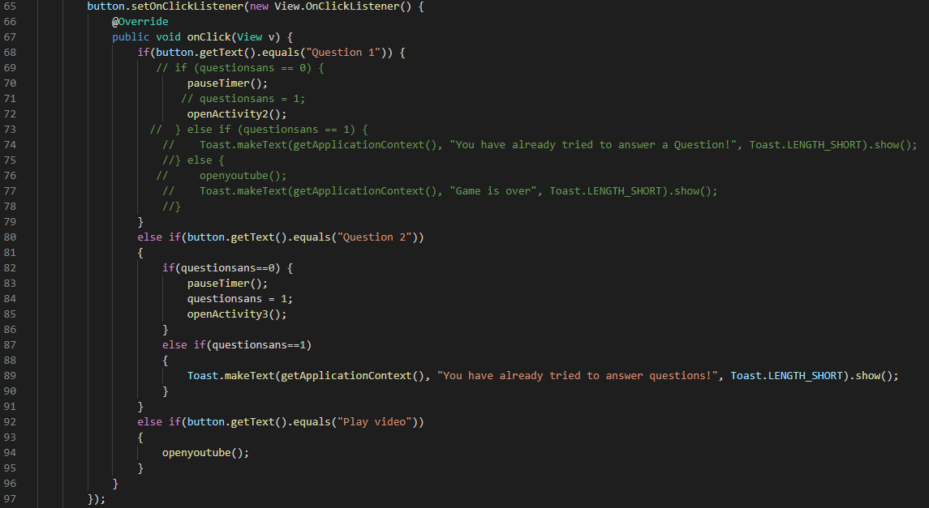

**2. CFG:**

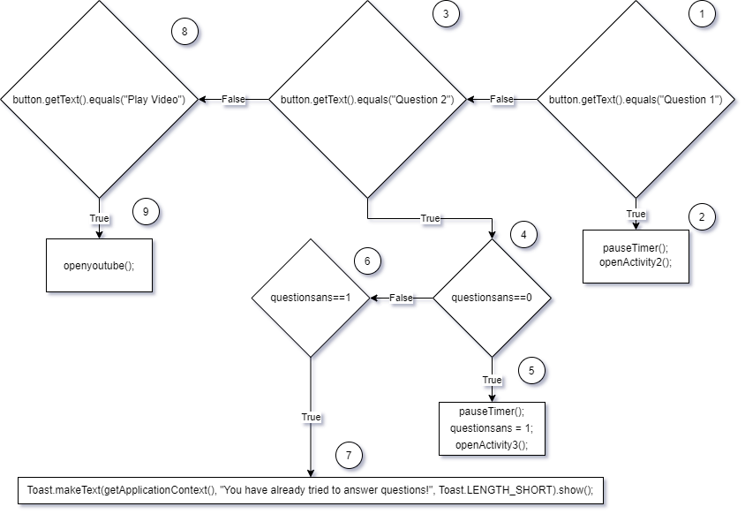

**3. Paths according to criteria**

We would use branch coverage and basis path coverage as the criteria. Paths according to the decided criteria are:

* 1(T) -> 2
* 1(F) -> 3(T) -> 4(T) -> 5
* 1(F) -> 3(T) -> 4(F) -> 6(T) -> 7
* 1(F) -> 3(T) -> 4(F) -> 6(F)
* 1(F) -> 3(F) -> 8(T) -> 9
* 1(F) -> 3(F) -> 8(F)

Cyclomatic Complexity: P + 1 = 5 + 1 = 6

**4. Test Cases for each path:**

|  |  |  |  |
| --- | --- | --- | --- |
| Path | Input | Expected Output | Actual Output |
| 1(T) -> 2 | Press button with text “Question 1” | Question 1 activity opens. | Question 1 activity opens. |
| 1(F) -> 3(T) -> 4(T) -> 5 | Press button with test “Question 2” | Question 2 activity opens. | Question 2 activity opens. |
| 1(F) -> 3(T) -> 4(F) -> 6(T) -> 7 | Press button with test “Question 2” | System: You have already tried to answer questions! | System: You have already tried to answer questions! |
| 1(F) -> 3(T) -> 4(F) -> 6(F) | Press button with test “Question 2” | Not possible. | Not possible. |
| 1(F) -> 3(F) -> 8(T) -> 9 | Solve the puzzle correctly, and then press button “Play Video” | Video plays. | Video plays. |
| 1(F) -> 3(F) -> 8(F) | No input. | No output. | No output. |